Best Practice: In Best Practice Software the smoking history is added via Family and Social History under Tobacco.
- Select the Tobacco tab.
- Select Non smoker to disable all of the fields in the screen. Select Ex smoker to record the patient’s previous tobacco intake, and when they started and stopped smoking.
- Select Smoker for current smokers, and record the method of smoking, Cigarettes per day, and Year started. To update the Last Updated field, tick Check box and Save if up to date.
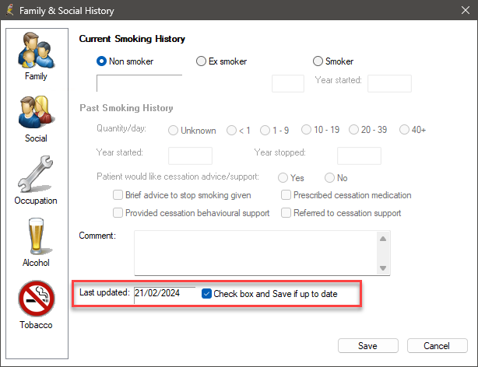

Changing from Smoker to Ex smoker- When a patient who has their smoking details entered in Bp Premier quits smoking, the Past Smoking History is automatically populated:
- The Packets/week field is populated from the Current Smoking History Packets per week.
- The Year started is taken from the Current Smoking History Year started field.
- The Year stopped field is set to the current year.

Medical Director- In Medical Director recording smoking history is under the patient details (Smoking Tab) or you can use this icon 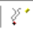 to open the patient details Smoking tab.
  - Select the Smoking tab in the patient details
  - Select New Assessment to update the details if the patient is a smoker or ex-smoker ensure you add all the other details such as number of cigarettes and Year commenced the Quit Date will default to the date of the assessment but can be changed.
  - Save
  - If the patient has never smoked, you can select this and save.

